

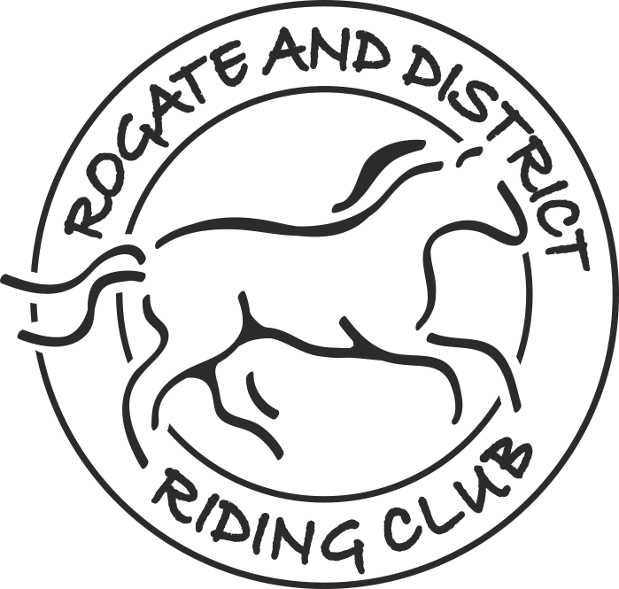
AREA 13 INTERMEDIATE (FORMERLY NOVICE )DRESSAGE
QUALIFIER & NON-QUALIFIER
TO BE HELD ON
Saturday 7th February 2026

TO BE HELD AT
Sands Farm Equestrian Centre, Northlands Road, Warnham, Horsham, RH12 3SQ
Competition Passes must be obtained from BRC to compete in a qualifier class
Entries close 4th February 2026
The Intermediate National Championships will take place on 24th -26th April at
Arena UK, Allington Lane, Allington, Grantham, NG32 2EF April 2023

RULES OF ENTRY
Your signature on the entry form shall be deemed as acceptance of these Rules and the Event’s Rules:-

- (a). British Riding Club Rules apply.
- (b). Venue rules and regulations apply at all times.
- (a). The decision of the judge(s) is final.
- (b). Competitors may not approach the judge(s) directly unless asked to do so.
- (c). Objections should be made in accordance with BRC Rules and/or the Organiser’s own rules as set out in the event schedule.
- Disclaimer of Liability. The Organisers or Landowners shall not be liable for any claims for loss or damages to competitors/onlookers/their servants/horses/ponies/other livestock/ pets/vehicles/equipment or any other items in connection with the Event or on the show ground however caused. Competitors are to satisfy themselves that they have assessed the risk factor in competing and it is a condition of entry that each participant will satisfy themselves as to their own ability to ride or handle their horse or pony safely and indemnify the Organisers against any accident or loss however caused.
- Health and Safety.
(a) Precautions will be taken to ensure the health and safety of ALL persons present. For
those measures to be effective, everyone must taken reasonable precautions to avoid and
prevent accidents and to OBEY the instruction of the Organisers, the Official BRC Stewards
and Event Stewards and Officials.
(b) Horse/ponies MUST NOT be tied up outside boxes/trailers and left unattended or tied to any
fences.
(c) If any horse/pony has been in contact with any infectious disease it should not attend any
events until it is certain that ALL risk of contamination has passed.
- Any person, whether competitor, family or friend, found to be abusive to any judges, Organisers or stewards will be reported to the relevant Area officials. The competitor could be eliminated and all parties could be asked to leave the venue. Remember ALL Officials and Stewards are volunteers.
- ALL riders must wear correctly fitting approved protective headgear conforming to PAS015 2011 OR SNELL 2016 carrying a BSI Kitemark. The headgear must have a retaining harness secured to the shell at more than two points. Headgear must be worn and be corrected fastened at ALL times when mounted. Riders’ hair must be neatly and firmly secured so it is no longer than shoulder length and longer hair to be secured in a hair net.
- No horse or pony under the age of 4 years may compete in any ridden class. Only horses and ponies competing in the event may be ridden on the venue site.
- STALLIONS MUST WEAR A STALLION DISC on both sides of their bridle and the correct coloured ribbon fixed in their tail (red, white & blue). No person shall allow a stallion for which he, she or they are responsible as owner, lessee, authorised agent or rider to compete or be prepared to compete in any competition without taking the adequate precaution to ensure other members of the public are not put at risk or injury.
- No refund of entry fees will be given after the closing date or after the times have been posted on our Facebook page and website, whichever occurs first, unless a valid vet/doctor’s certificate is produced.
- Cancellation. In the event the competition is cancelled, refunds will be given, less a small admin fee if any costs have been incurred.
Rogate & District Riding Club
is affiliated with British Riding Clubs
SHOW SECRETARY:
Christine Gay
Mobile. 07887 505257
Email. rogateridingclub@gmail.com
ENTRY FEES & PAYMENT:
No entries accepted without payment
Entry fee per rider - £22.00
Payment via bank transfer to:
Account name: Rogate & District Riding Club
Account no: 23 09 00 94
Sort code: 20-67-49

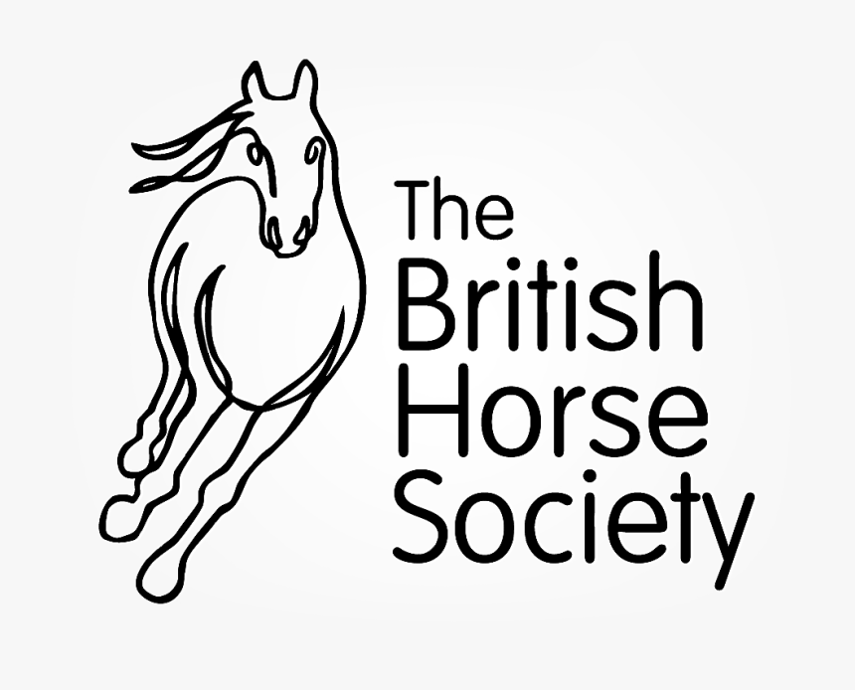
Classes
CLASS 1 : Junior Intermediate Qualifier - Teams of 4 & Individuals
(Teams of 4 riders require 1 rider to each test)
Intro 3 (2024) and Prelim 1 (2024),
Prelim 2 (2024) and Novice 1 (2024)
CLASS 2: Senior Intermediate Qualifier - Teams & Individuals
(Teams of 4 riders require 1 rider to each test)
Intro 3 (2024) and Prelim 1 (2024)
Prelim 2 (2024) and Novice 1 (2024)

P

Novice 24 (2010) and Novice 27 (2007)
CLASS 3: Junior & Senior Intermediate NON-Qualifier - Teams & Individuals
(Teams of 4 riders, can be mixed junior & senior, require 1 rider to each test)
Intro 3 (2024) and Prelim 1 (2024)
Prelim 2 (2024 and Novice 1 (2024)
P
Prelim 2 (2024 and Novice 1 (2024)

I

Prelim 7 (2002) and Prelim 12 (2005),
Novice 24 (2010) and Novice 27 (2007)
Two BRIDlE numbers or bib NuMBER MuSt BE WORN.
Rosettes 1st to 6th place in all classes.
Times will be emailed to the Team Managers on Thursday 5th February 2026, and will also be available on RDRC website www.rogaterc.com
Enquiries on the day to the Show Secretary.

- Competitors’ riding hats are required to be tagged.
- Competitors’ horse’s passport must be taken to the Secretary’s Office on arrival to show valid yearly vaccinations. Failure to do so will result in elimination.
- The competition will run under BRC rules.
- All classes are 20 x 40 arena.
NB: Non-qualifier classes will only be run if time permits, and entries will be treated on a first come first served basis.
The organisers are to be informed of any changes to teams which occur after close of entries, as soon as possible.
All clubs competing must supply a helper for half a day, helpers name and contact details supplied on entry form.

Every Area 13 Club entering a team, will each provide a minimum of one helper for half a day, to either write, steward or generally assist in the running of the competition.

*QUALIFIER*
*QUALIFIER*
*non-QUALIFIER*

